|  |
| --- |
| Comp 3900 industry project |
| Chat Program |
| An Android Chat Application |
|  |
| **Robin Hsieh, German Villarreal & Mateusz Siwoski** |
|  |

|  |
| --- |
|  |

# Abstract

The chat program is a chat program for the Android OS, meant to be used with a wireless device. The program will allow users to send text messages to each other and will display by a custom username who sent the message.

This document describes the functions and features of the program and general operation of the application. The application is meant to be a general chat program and is designed to be capable of supporting additional features such as picture messaging.

# Table of Contents

Abstract 1

Table of Contents 2

Introduction 3

Features 4

Devices & Operating System 4

Design: 5

Gantt Chart: 6

Conclusion 7

Instructions for Installations: 8

How to install through APK: 8

Test Cases 9

Figures 10

Test 1: Initial Start Up (PASS) 10

Test 2: Typing Text (PASS) 10

Test 3: Typing multiple text (FAIL) 11

Test 4: Custom username (Pass) 11

Test 5: Display typed text correctly (PASS) 12

# Introduction

For our industry project, we have been tasked to create a chat application for the Android OS. The application uses peer-to-peer to connect with other users and allows for communication between at least two devices. The device is meant for the android OS, allowing for touch screen typing.

# Features

The following features have been implemented:

* Custom Username: Allows, upon start-up of the program, a user to enter a custom username to display in the general chat screen what they have said.   
    
  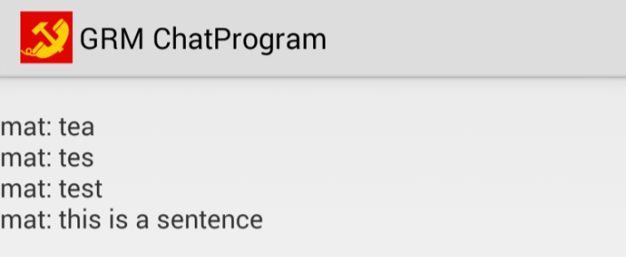
* Auto Scrolling of text: As messages have reached the end of the defined window size, the text will be appended to the bottom and the screen will descend as more messages are sent.

# Devices & Operating System

The chat program is dependent on any device that is running the Android OS 2.4 and higher. The devices that were used in testing were the Nexus 4, Nexus 7 and Samsung Galaxy S3.

# Design:

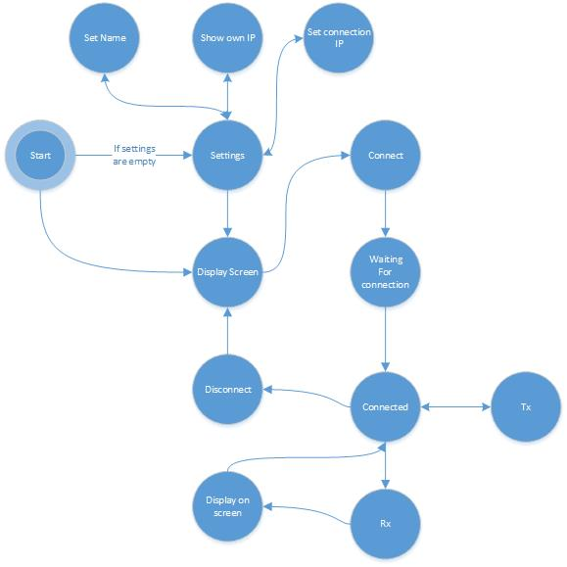

# Gantt Chart:

|  |  |  |  |  |
| --- | --- | --- | --- | --- |
| Task Name | Duration | Start | Finish | Predecessors |
| **Android Chat Program** | **51 days** | **Mon 9/23/13** | **Mon 12/2/13** |  |
| **Implementation** | **5 days** | **Mon 9/23/13** | **Fri 9/27/13** |  |
| Report | 5 days | Mon 9/23/13 | Fri 9/27/13 |  |
| **Design stages** | **5 days** | **Mon 9/30/13** | **Fri 10/4/13** |  |
| Design | 5 days | Mon 9/30/13 | Fri 10/4/13 | 3 |
| Setup | 5 days | Mon 9/30/13 | Fri 10/4/13 | 3 |
| **Application Development** | **33 days** | **Mon 10/7/13** | **Wed 11/20/13** |  |
| Android display screen | 3 days | Mon 10/7/13 | Wed 10/9/13 | 4,3 |
| Establish connection with devices | 10 days | Thu 10/10/13 | Wed 10/23/13 | 8 |
| Read information | 10 days | Thu 10/24/13 | Wed 11/6/13 | 9 |
| Write information | 10 days | Thu 11/7/13 | Wed 11/20/13 | 10 |
| **Testing** | **8 days** | **Thu 11/21/13** | **Mon 12/2/13** |  |
| Testing | 5 days | Thu 11/21/13 | Wed 11/27/13 | 11 |
| Additional Features | 3 days | Thu 11/28/13 | Mon 12/2/13 | 11,13 |

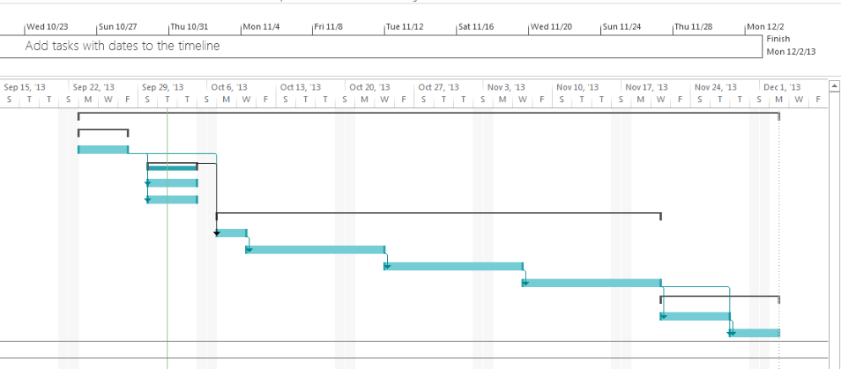

# Conclusion

Asdfa

# Instructions for Installations:

## How to install through APK:

Before anything, to ensure being able to install our application, look online for tutorials on how to install Android Applications without the market if you are unfamiliar with installing an application without the Google PlayStore.

1. 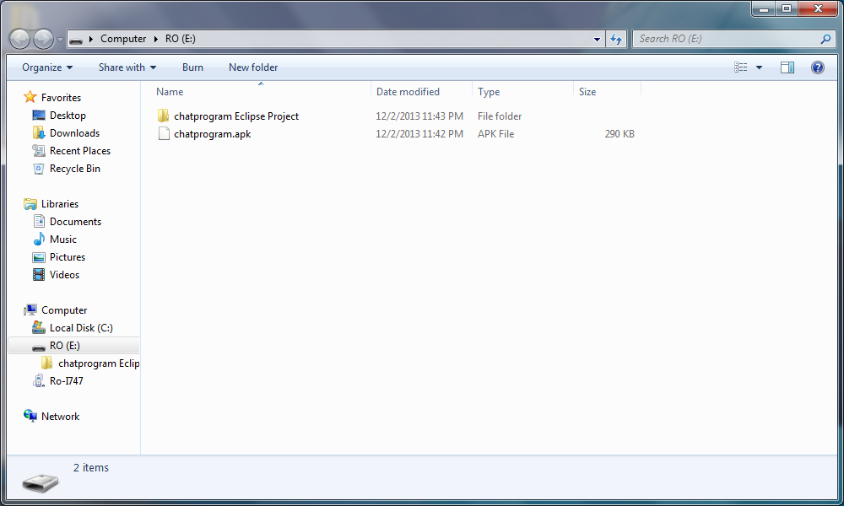Navigate to the APK in your company.
2. Connect Android device through USB, and open devices to view files.

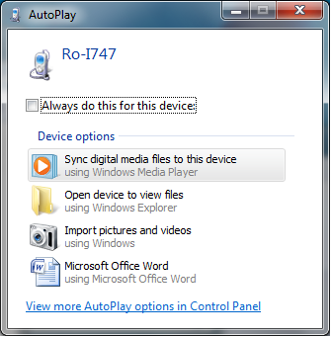

## E:\Dropbox\2013 BCIT Fall\COMP 3900 Projects\Instructional Screenshots\apk3.png

1. Navigate to folder of your choice, and place the APK into the folder.

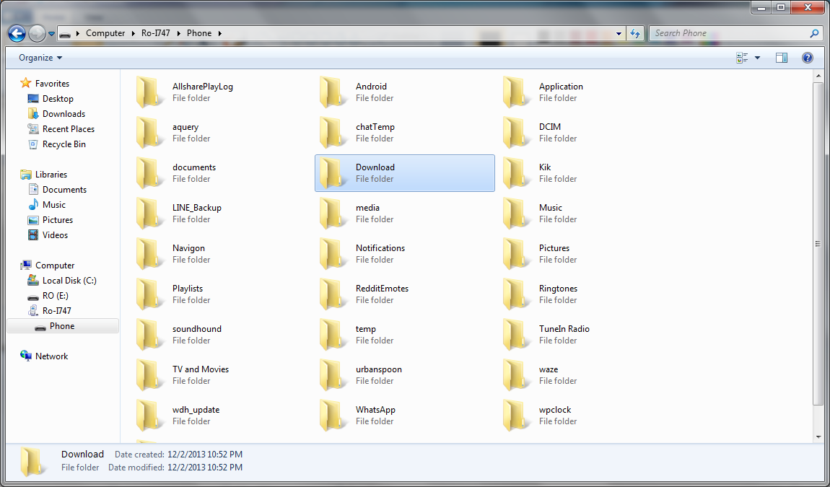

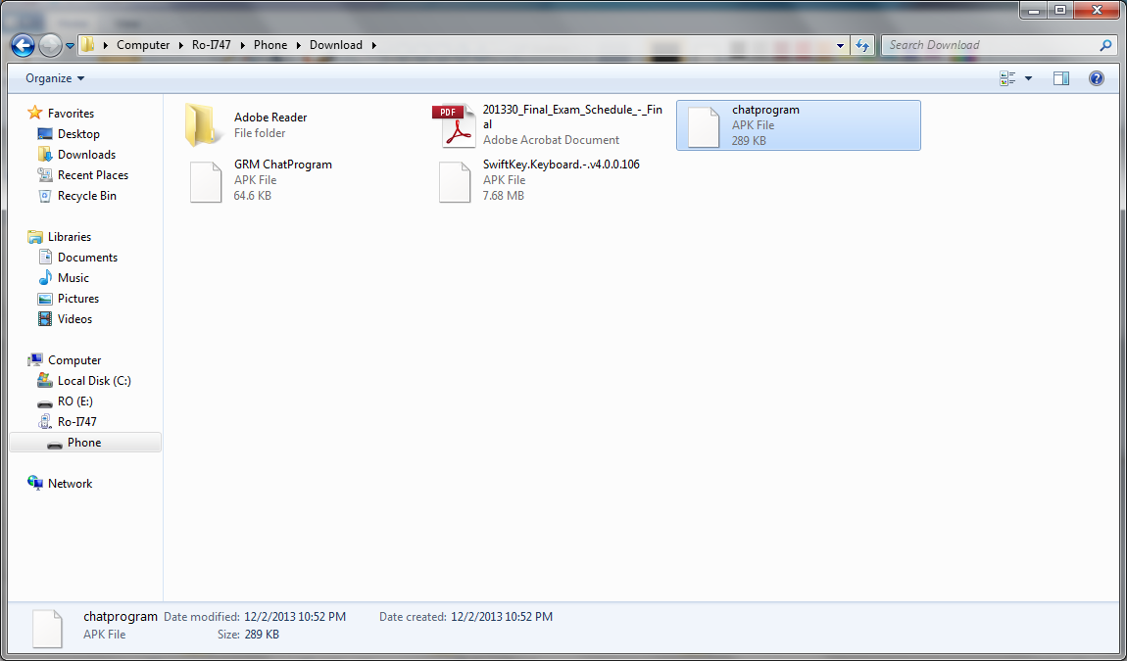

1. Using a file manager application (Any file manager downloaded from the App Store, Ex. ASTRO File Manager, etc.) Locate the APK within your phone.

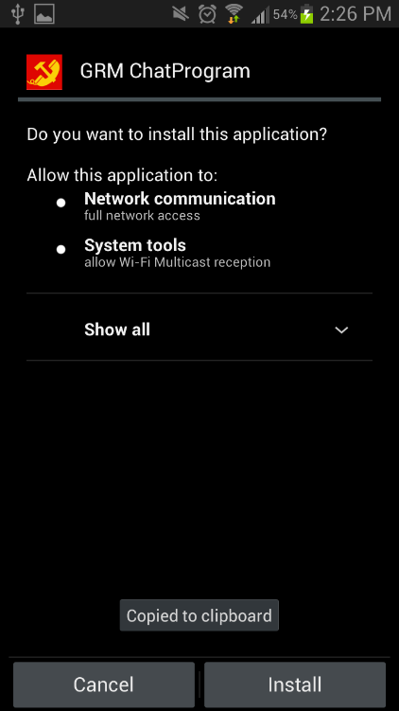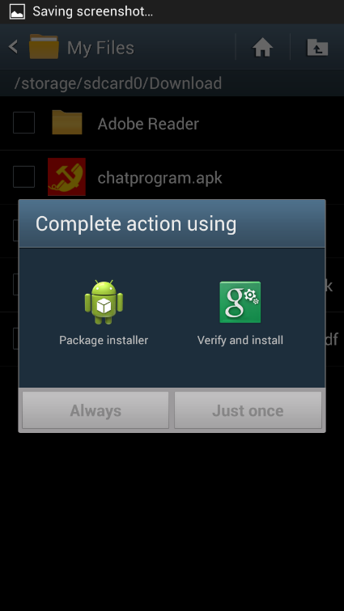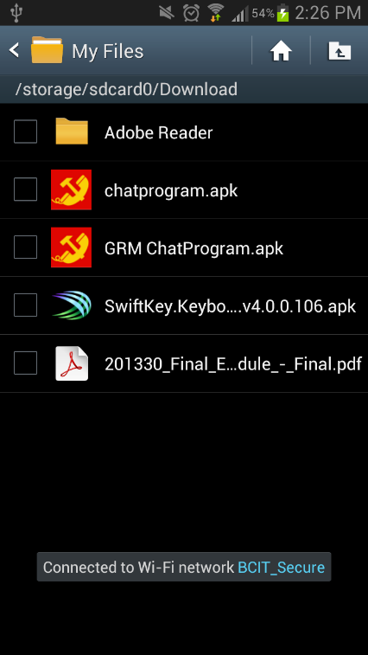

## How to install through Eclipse:

# Test Cases

|  |  |  |  |  |  |
| --- | --- | --- | --- | --- | --- |
| **Test** | **Tests Description** | **Tools Used** | **Expected Result** | **Pass/Fail** | **Notes** |
| 1 | Initial Start Up | Nexus 4 | The program should open on an Android device | Pass | See Figure 1 |
| 2 | Typing Text | Nexus 4 | Text written with the keyboard should display | Pass | See Figure 2 |
| 3 | Typing multiple lines | Nexus 4 | Lines of text would be on separate lines. | Fail | See Figure 3 |
| 4 | Custom Username | Nexus 4 | Able to add a custom username to conversation | Pass | See Figure 4 |
| 5 | Displayed typed text correctly | Nexus 4 | Text is on its own line each time entered and not overwritten | Fail | See Figure 5 |
|  |  |  |  |  |  |
|  |  |  |  |  |  |

# Figures

## Test 1: Initial Start Up (PASS)

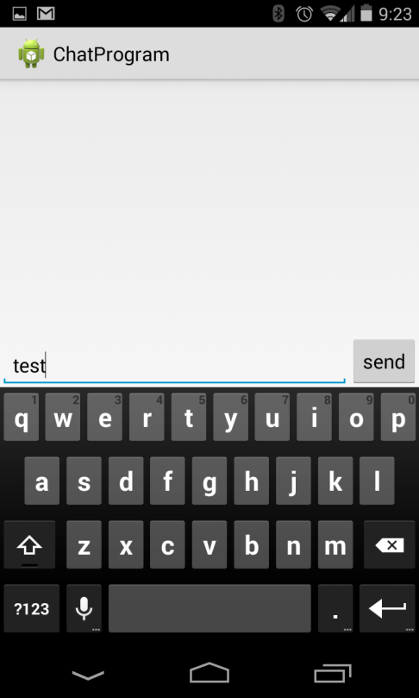

## Test 2: Typing Text (PASS)

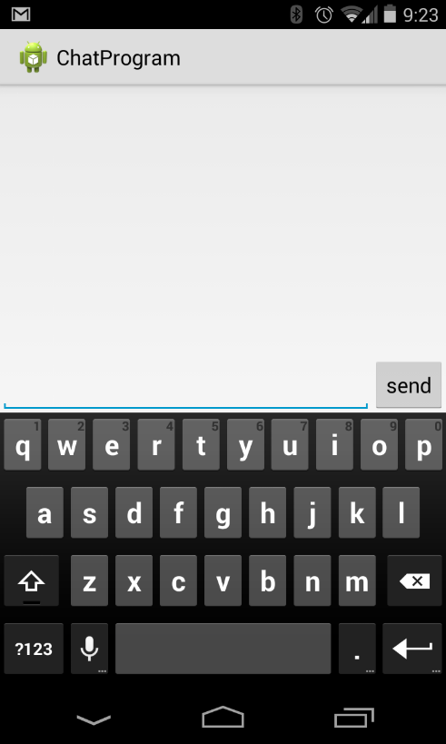 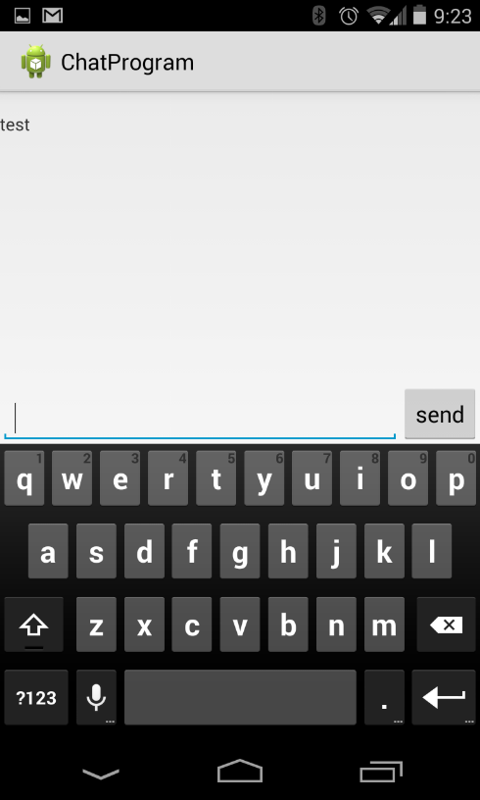

1. (b)

## Test 3: Typing multiple text (FAIL)

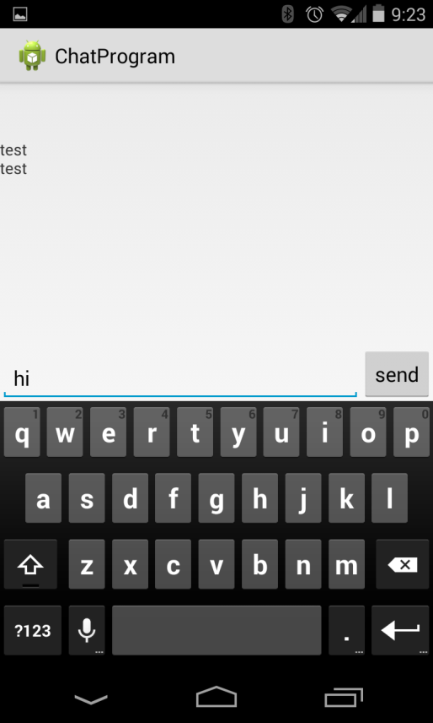 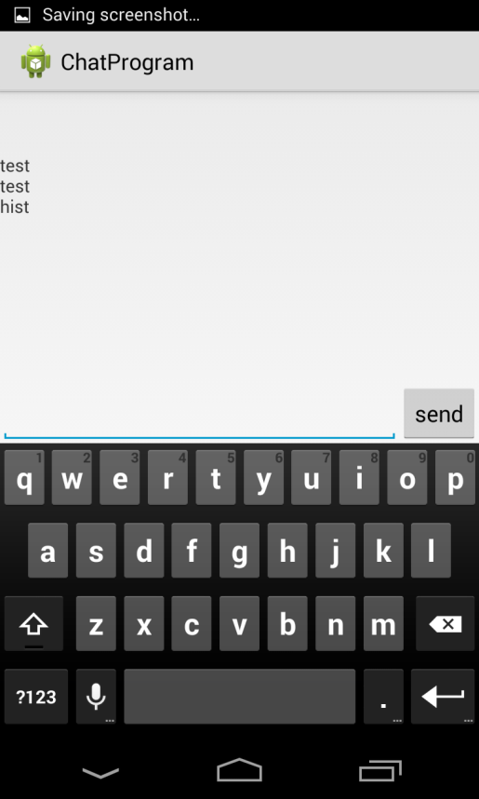

(a) (b)

## Test 4: Custom username (Pass)

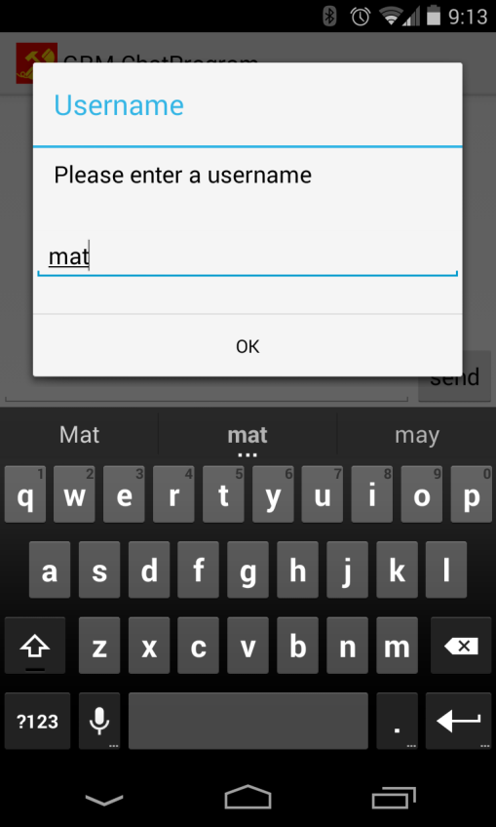

## Test 5: Display typed text correctly (PASS)

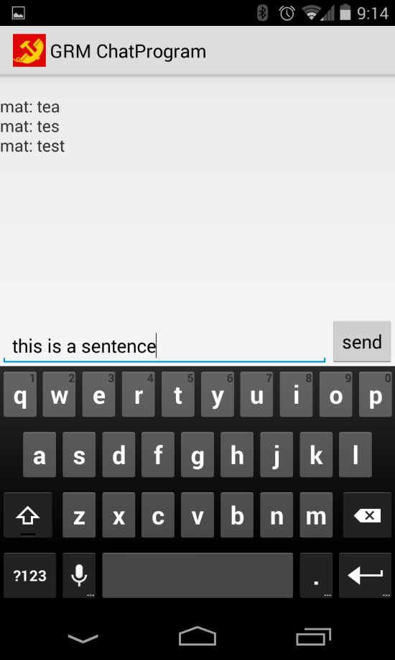 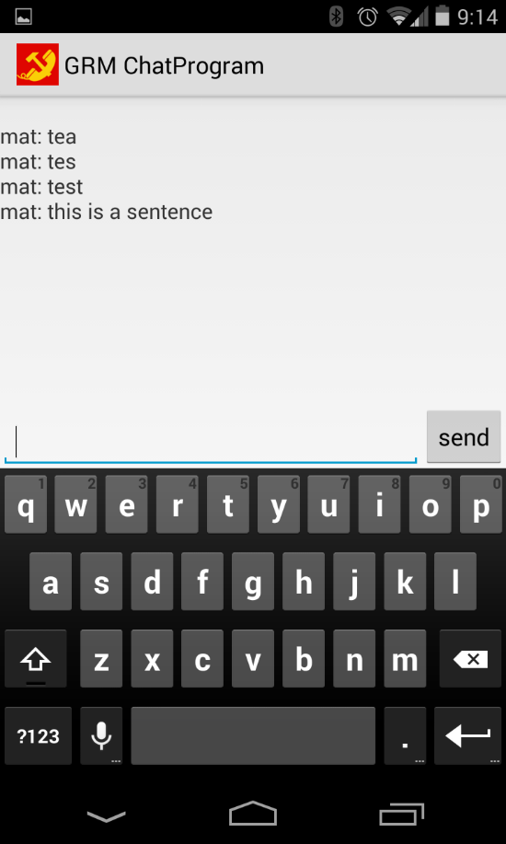

(a) (b)